Checkmk — Complete Step-by-Step

PART 1 — Update Ubuntu
Open your Ubuntu terminal and run:
sudo apt update
Your document specifically starts the Ubuntu installation with this command.
Then I recommend also running:
sudo apt upgrade -y
If Ubuntu asks you for your password, enter your Ubuntu user's password.

PART 2 Download Checkmk
Your document specifies Checkmk 2.5.0p11 Ultimate for Ubuntu/Debian.
Run:
wget https://download.checkmk.com/checkmk/2.5.0p11/check-mk-ultimate-2.5.0p11_0.resolute_amd64.deb

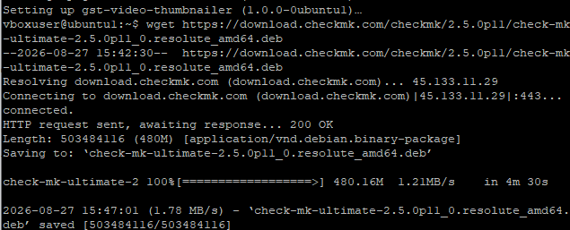

After it finishes, check that the file exists:
ls
You should see something similar to:
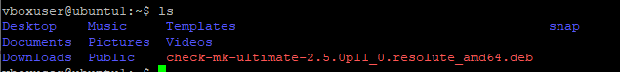

PART 3 — Install Checkmk
Run:
sudo apt install ./check-mk-ultimate-2.5.0p11_0.resolute_amd64.deb
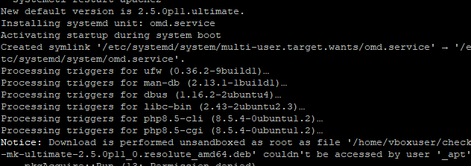

PART 4 — Verify the Installation
Run:
omd version

PART 5 — Create the Checkmk Monitoring Site
Your document uses the site name:
monitoring
Run:
sudo omd create monitoring

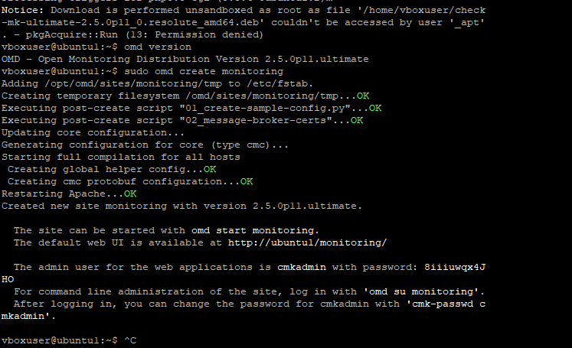

PART 6 — Change the cmkadmin Password
Then run:
cmk-passwd cmkadmin
It will ask for the new password.
Enter your new password.
Then confirm it when asked.
exit

PART 7 — Start Checkmk
Now start your monitoring site:
sudo omd start monitoring
Your document gives this exact command.
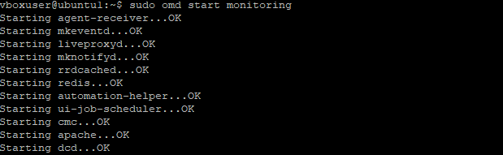

PART 8 — Find the Ubuntu Server IP Address
We need the IP address so you can open Checkmk in a browser.
Run:
ip addr

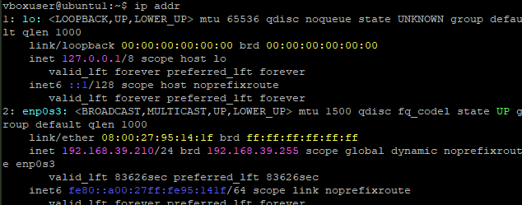

PART 9 — Open Checkmk in Your Browser
On the computer where you're accessing the Checkmk server, open a browser.
Use:
http://192.168.39.210/monitoring/check_mk/login.py

PART 10 — Log Into Checkmk
Use:
Username
cmkadmin
Password
8iiiuwqx4JHO

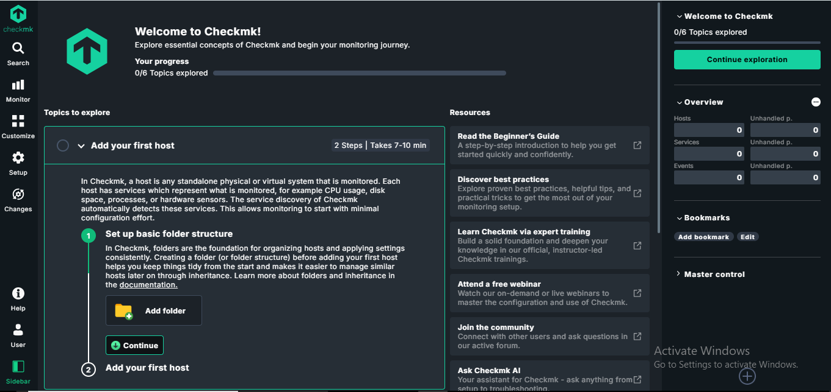

PART 11 — Check Whether the Site Is Running
If you want to verify from Ubuntu, run:
sudo omd status monitoring
You should see the Checkmk services running.

PART 12 — Install the Checkmk Agent
Your document also contains instructions for installing the Checkmk agent on a monitored machine.
It says to download the agent from the Checkmk dashboard and provides this type of URL:
http://192.168.39.210/monitoring/check_mk/agents/

Download the Ubuntu agent
On the Ubuntu machine you want to monitor, open the terminal and run:
wget http://192.168.39.210/monitoring/check_mk/agents/check-mk-agent_2.5.0p11-1_all.deb
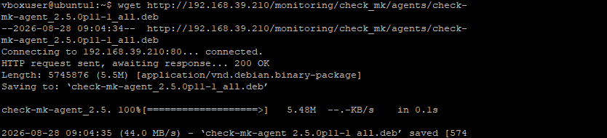
Then check that it downloaded:
ls
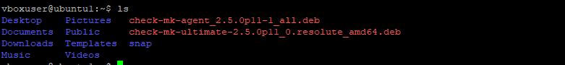

Install the Checkmk agent
On the Ubuntu host you want to monitor, run:
sudo apt install ./check-mk-agent_2.5.0p11-1_all.deb
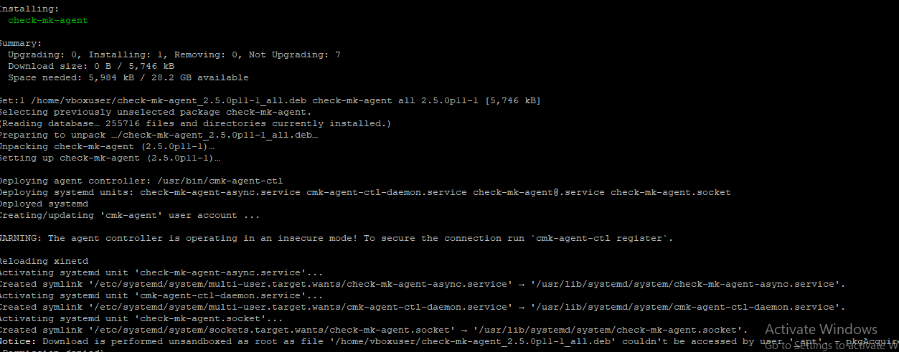

Verify the agent
Run:
check_mk_agent


